Collision risk in narrow aisles: HUBTEX introduces Clear Aisle Assist
In narrow-aisle warehouses, multidirectional forklifts often operate with minimal safety distances. Collisions with protruding loads pose a constant safety risk. To effectively minimise this risk, HUBTEX has developed a patented Clear Aisle Assist: A system of laser sensors that identifies protruding loads early, alerts the driver, and automatically reduces speed.

Challenges in narrow aisles: minimal clearance, limited visibility
HUBTEX multidirectional sideloaders are frequently utilised in narrow-aisle warehouses. To maximise storage capacity, these vehicles operate within guidance systems with very limited safety clearance, often with less than 100 millimetres on each side. This increases space efficiency but restricts the driver’s visibility. It becomes particularly critical when long items are stored at an angle or when neighbouring loads are inadvertently moved during retrieval. Parts may protrude into the aisle and aren't always visible in time from the cabin, especially on the engine side. This can lead to contact issues and costly damage to the chassis, battery, cabin or rack system. In the timber, metal and general industrial trade, with hundreds of moves per day, this scenario is commonplace.

Patented solution: monitoring with laser-based sensors
To reduce these risks, HUBTEX has developed Clear Aisle Assist that oversees the vertical danger zones along the rack systems and reacts automatically if needed. The system utilises Lidar sensors to assess vertical planes in the vehicle's environment. Sensors are mounted at suitable positions based on vehicle configuration and scan both forwards and in reverse. This ensures early detection of protruding loads, whether the forklift enters the aisle forwards or backwards. The monitored area dynamically adjusts to key parameters, with speed, lift height and configuration determining the size of the protective zones. This allows for precise, needs-based detection of potential collision zones without burdening the driver with additional tasks.
Classification: The Clear Aisle Assist does not replace personal protection technology but supplements it with collision protection for loads protruding from the rack system.

Now available for the PHOENIX series
If the system detects an obstacle, it issues a warning first. If necessary, the system automatically reduces speed to avoid contact or minimise its consequences. The goal is an assistance system that effectively enhances the driver's focus and maintains material flow in tight layouts. "Our aim was to develop an assistance system that actively supports the driver without adding extra burden", states Michael Röbig, Head of Product Management at HUBTEX. "The Clear Aisle Assist recognises dangerous situations early and can, if needed, not only warn but also automatically reduce the vehicle's speed". The system is now available for the PHOENIX series and complements existing personnel protection scanners by providing protection against goods protruding into the aisle.

HUBTEX will provide details about the Clear Aisle Assist at the upcoming LogiMAT trade show in Hall 10, Stand 10C31.

Last updated: 5 January 2026
Length: 3,199 characters including spaces
Images: 3 (© Hubtex)

Captions

Image 1
Lines of sight in narrow aisles: The sensors monitor the rack system and detect protruding loads.
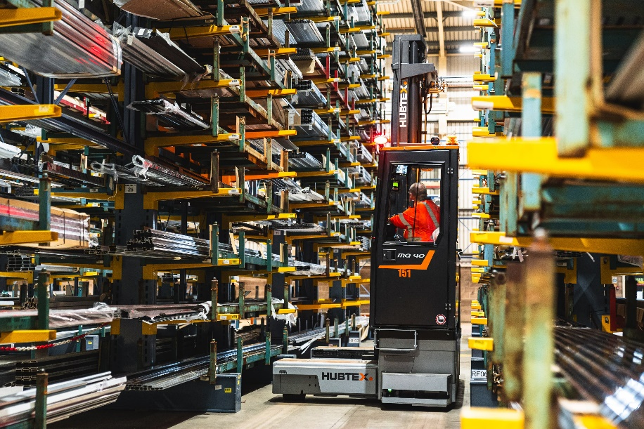

Image 2
Detailed view of the compact integrated sensor and protection unit on the vehicle chassis of a PHOENIX multidirectional sideloader.
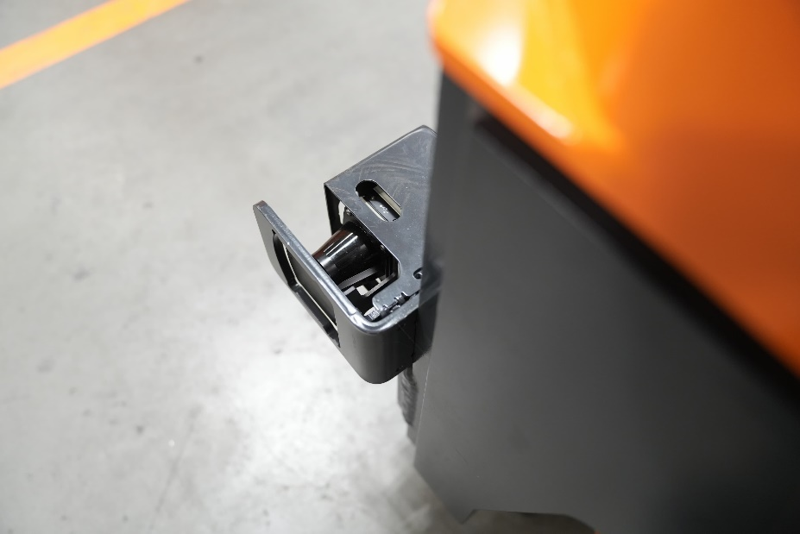
Image 3
Operating principle: The sensor detects misaligned item 4, alerts to the danger, and slows down the vehicle.
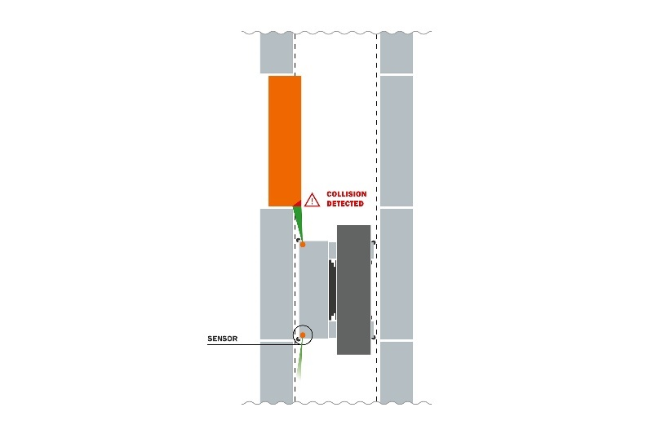

About HUBTEX Maschinenbau GmbH & Co. KG
The HUBTEX Group, along with its affiliated companies Hubtex Maschinenbau GmbH & Co. KG, Genkinger GmbH, stabau GmbH and DIMOS Maschinenbau GmbH, employs more than 1300 people worldwide. HUBTEX Maschinenbau is the leading international manufacturer of multidirectional forklifts, sideloaders, 6 purpose-built industrial trucks and special equipment for transporting long, heavy and bulky goods. The products are designed to enable production and trading companies to achieve an efficient flow of materials and to allow goods handling in the narrowest of aisles. HUBTEX has built up a reputation for comprehensive advice, global service and innovation. As a result, the 520-strong company headquartered in Fulda is able to provide the perfect solution for every customer requirement: from basic models to highly developed series trucks and specially developed solutions.

Company contact information
HUBTEX Maschinenbau GmbH & Co. KG
Marlen Möller • Marketing
Technologiepark Fulda • Werner-von-Siemens-Straße 8 • 36041 Fulda • Germany
Tel.: +49 (0)661 8382235 • Fax: +49 661 8382120
E-mail: marlen.moeller@hubtex.com • Website: www.hubtex.co.uk
Digital text and image material for your article can be found at:
https://www.hubtex.com/en-gb/company/news-press

