Strategic Expansion in the Heavy-Duty Compact Forklift Market
HUBTEX Integrates M Fahrzeugbau Expertise into Its Compact Forklift Portfolio

HUBTEX is sharpening its strategic focus on the heavy-duty compact forklift market, with the aim of offering customers in heavy-load handling an even more comprehensive range of solutions. A key milestone in this effort is the integration of the expertise of compact forklift specialist M Fahrzeugbau. One outcome of this development is a newly engineered compact forklift that will be launched under the model name M-TEX. Going forward, this platform will serve as HUBTEX’s standard solution for load capacities from 11 to 15 tons. At the same time, the company is consolidating all compact forklift solutions within the HUBTEX Group including relevant vehicles from DIMOS, to create a streamlined, clearly structured product offering for customers.

Since 1948, M Fahrzeugbau developed and manufactured custom heavy-duty compact forklifts with load capacities ranging from 6 to 40 tons, tailored for confined operating environments such as those found in metal processing, foundries, steel mills, rolling mills, and the paper industry. Through the acquisition, HUBTEX secured extensive trademark rights as well as valuable engineering, customer, and sales data.

HUBTEX’s objective is to strategically expand the Group’s capabilities in the heavy-duty compact forklift segment and further reinforce its position as the global market leader. Drawing on the acquired technological expertise, the company plans to develop new vehicle concepts and continue advancing the heavy-duty compact forklift segment. HUBTEX is also systematically incorporating the compact forklift expertise of its subsidiary DIMOS into its broader portfolio.

On the technical side, HUBTEX is methodically integrating M Fahrzeugbau’s engineering data into the Group’s existing development platform. Compact forklifts offer clear advantages wherever heavy loads must be moved in extremely tight spaces. Compared with conventional heavy-duty forklifts, they can be up to 25% narrower and 20% shorter. M Fahrzeugbau’s trucks in particular were regarded as market-leading for their exceptionally compact design. This defining characteristic will remain a core feature of HUBTEX compact forklifts moving forward.

“By integrating the brand, engineering, and sales data from M Fahrzeugbau, we are creating a broad foundation for developing new and innovative solutions in the compact forklift segment,” said Hans-Joachim Finger, General Manager of the HUBTEX Group. “At the same time, together with our other heavy-duty handling solutions, such as platform trucks, heavy-duty multidirectional forklifts, and automated coil transporters, we are able to offer a comprehensive portfolio for demanding heavy-duty applications across these industries.”

The first result of this integration within the HUBTEX portfolio is a new model variant, M-TEX, in the 11- to 15-ton capacity range. It incorporates key design features from the former M portfolio, including an exceptionally compact frame width made possible by an innovative drive and transmission layout. At the same time, the mast geometry and enhanced operating and control concept provide excellent visibility of the load. By combining M Fahrzeugbau’s
latest engineering developments with HUBTEX’s extensive expertise, the company has also significantly improved ergonomics, operator comfort, and service accessibility.

“With the new M-TEX platform, we are creating a future-ready foundation that combines proven design concepts with our own engineering expertise while strategically expanding our compact forklift portfolio,” added Hans-Joachim Finger, General Manager of the HUBTEX Group.

Visit us at the upcoming LogiMAT trade show in Hall 10, Booth 10C31, to learn more about the new M-TEX.

As of: 17. March 2026
Length: 3.738 characters including spaces
Images: 4 (© Hubtex; Schäfer Werke GmbH)

Captions
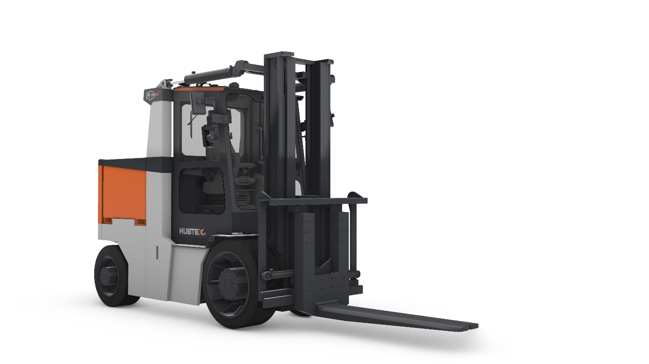
Image 1
The new M-TEX makes it easy to move heavy loads in extremely tight spaces thanks to a design that is up to 25% narrower and 20% shorter. (Source: HUBTEX)

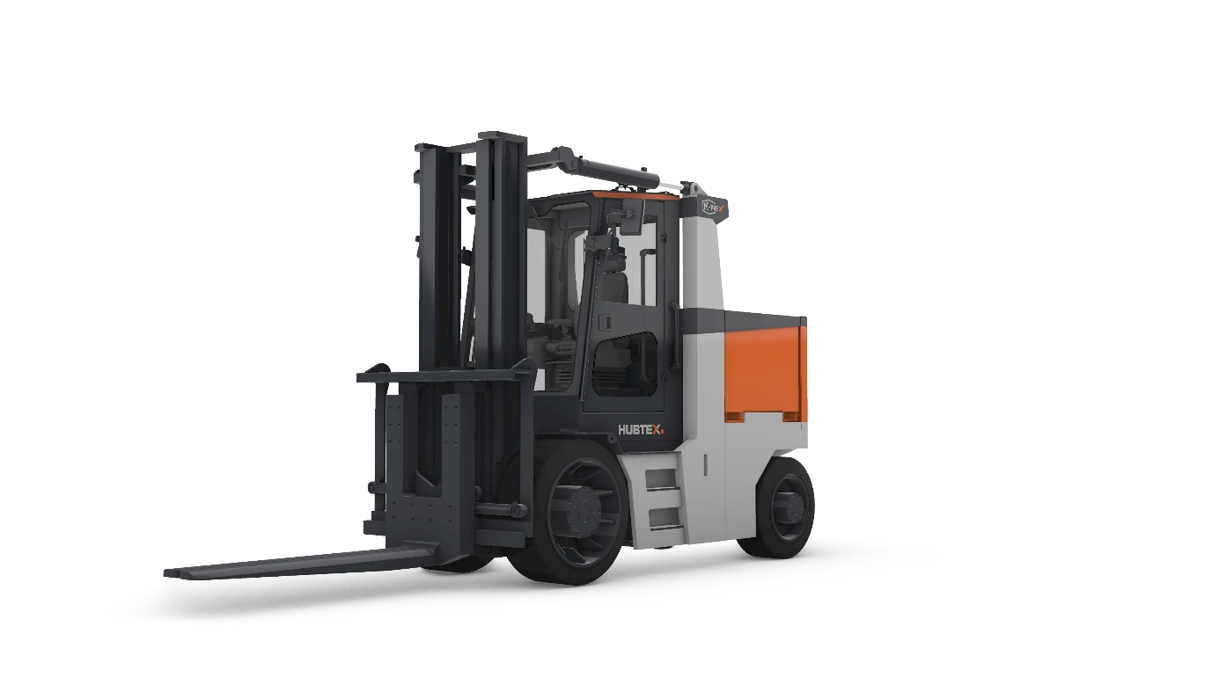
Image 2
The new M-TEX also offers major advantages in terms of ergonomics, operator comfort, and service accessibility. (Source: HUBTEX)

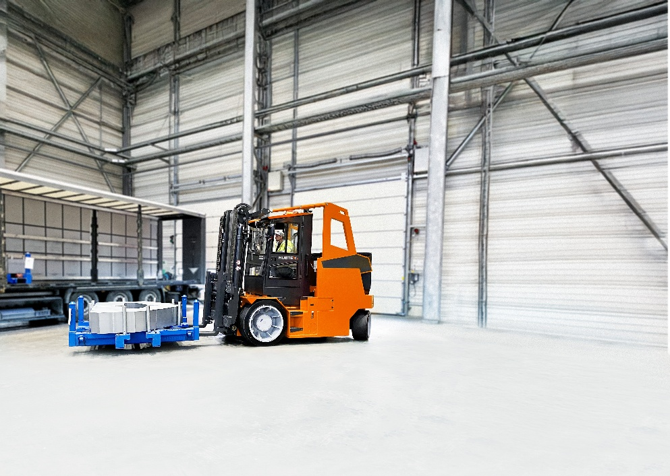
Image 3
The Roxx heavy-duty compact forklift from HUBTEX, reengineered using new design data. (Source: HUBTEX)
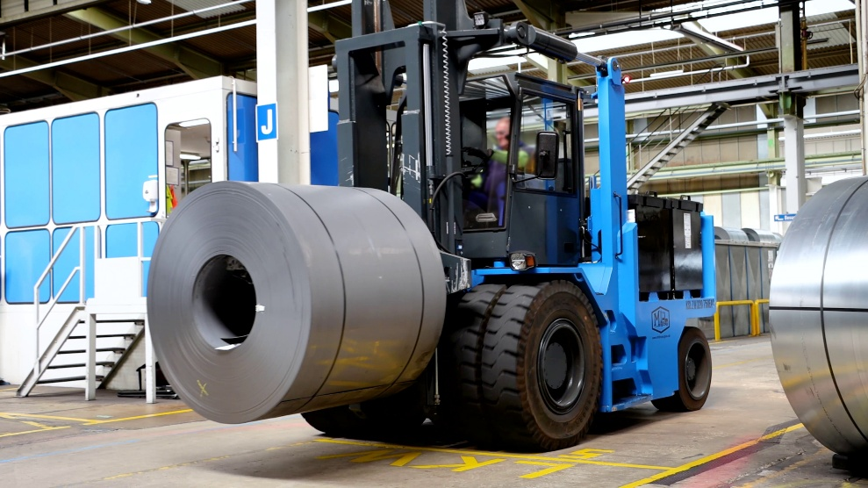
Image 4
Existing M Fahrzeugbau customers can rest assured: service and spare parts support will continue to be guaranteed by HUBTEX. (Source: Schäfer Werke GmbH)

Über HUBTEX Maschinenbau GmbH & Co. KG
Die HUBTEX Gruppe mit ihren verbundenen Unternehmen HUBTEX Maschinenbau GmbH & Co. KG, Genkinger GmbH, stabau GmbH und DIMOS Maschinenbau GmbH beschäftigt weltweit mehr als 1100 Mitarbeiter. HUBTEX Maschinenbau ist der international führende Hersteller von Mehrwegestaplern, Seitenstaplern, Kommissionierfahrzeugen spezialgefertigten Flurförderzeugen und Sonderfahrzeugen für den Transport von langen, schweren und sperrigen Gütern. Ihr Einsatz dient dem effizienten Materialfluss und Warenumschlag bei engsten Gangverhältnissen von Produktions- und Handelsunternehmen. Umfassende Beratung, weltweiter Service und Innovationsstärke zeichnen HUBTEX aus. So hat das 520 Mitarbeiter starke Unternehmen mit Hauptsitz in Fulda für jede Kundenanforderung die passende Lösung: von der Basisversion über ausgereifte Serienfahrzeuge bis zur individuellen Spezialentwicklung.

Unternehmenskontakt
HUBTEX Maschinenbau GmbH & Co. KG
Marlen Möller • PR HUBTEX Gruppe (HUBTEX & DIMOS)
Technologiepark Fulda • Werner-von-Siemens-Straße 8 • 36041 Fulda
Tel.: +49 661 8382235 • Fax: +49 661 8382120
E-Mail: marlen.moeller@hubtex.com • Website: www.hubtex.com

